Methodology to Estimate Groundwater Quality Accessed by Domestic Wells in California

State Water Resources Control Board

Division of Water Quality

Groundwater Ambient Monitoring and Assessment Unit

February 2020



Table of Contents

Acronyms 1

Executive Summary 1

Introduction 2

Background 2

Intended Use of this Analysis 3

Data Sources 3

Methodology 4

Data Processing 4

DWR Well Construction Records 4

Water Quality Data Standardization 4

Depth Filter 5

Water Quality Estimation 7

Recent Data Analysis 9

Identification of Priority Sections 9

Estimated Domestic Wells Located Within Priority Sections 9

Results 10

Domestic Wells in Priority Sections 10

Secondary Maximum Contaminant Level Chemicals 12

Appendix A Data Standardization A-1

Appendix B Well Depth Filter B-1

Appendix C Data Coverage C-1

Appendix D Sensitivity Evaluation D-1

Timeframe for Including Water Quality Data D-1

Depth Parameters D-2

Appendix E Comparisons with other water quality analyses E-1

Ransom et al. (2017) Central Valley nitrate prediction – domestic well depth E-1

Anning et al. (2012) USGS Basin Predictions for Nitrate and Arsenic E-2

USGS Shallow Aquifer Assessment Study Areas E-2

CV-SALTS Central Valley Upper Zone Nitrate E-3

Human Right to Water Tool E-3

# Acronyms

1,2,3-TCP – 1,2,3-Trichloropropane

DDW – Division of Drinking Water

DWQ – Division of Water Quality

DWR – Department of Water Resources

GAMA – Groundwater Ambient Monitoring and Assessment

MCL – Maximum Contaminant Level

NWIS – National Water Information System (from USGS)

OEHHA – Office of Environmental Health Hazard Assessment

OSWCR – Online System for Well Completion Reports

PLSS – Public Land Survey System

SADW – Safe and Affordable Drinking Water

USGS – United States Geological Survey

# Executive Summary

The State Water Resources Control Board (State Water Board) was appropriated funding to implement a Needs Analysis on the state of drinking water in California (SB 862, 2018). The State Water Board Division of Drinking Water (the lead division for this effort) identified the following three Elements for the Needs Assessment:

1. Identification of Public Water Systems in Violation or At Risk;
2. Identification of Domestic Well and State Small Water Systems At Risk; and
3. Cost Analysis for Interim and Long-Term Solutions.

The work described in this report was completed by the Division of Water Quality Groundwater Ambient Monitoring and Assessment (GAMA) Unit in support of Element #2, above. Results of the analysis described in this paper will be used by the University of California Los Angeles and others contracted by DDW to support implementation of Element #3. The results of this analysis may also provide a starting point for identifying domestic well communities at high risk of contamination in support of the Safe and Affordable Drinking Water program (SADW).

The California Health and Safety Code defines a “domestic well” as a groundwater well used to supply water for the domestic needs of an individual residence or a water system that is not a public water system and has no more than four service connections (HSC § 116681). Domestic well water sources are not regulated, and there is currently no comprehensive database of domestic well water quality results. This project uses existing nearby water quality data to estimate water quality accessed by domestic well sources. The resulting estimation of groundwater quality can be combined with domestic well location and density information from the Department of Water Resources (DWR), or other sources, to identify areas in California where domestic wells may access groundwater with constituents of concern that may be above regulatory levels.

Existing groundwater quality data in the GAMA Groundwater Information System was filtered by time and depth to better represent domestic well water quality. In addition, several steps were taken to address non-detect values in the database. Groundwater quality was estimated for all chemicals for which there is a primary or secondary maximum contaminant level (MCL/SMCL). The final water quality estimation layer consists of a twenty-year average detection level per Public Land Survey System (PLSS) section per chemical, and a count of the number of recent detections above the MCL per PLSS section per chemical.

Using the methodology described in this paper, domestic well water quality values were estimated for PLSS sections that contain 99 percent of domestic wells in California, according to DWR domestic well density statistics. The constituents with estimated concentrations that most frequently exceeded regulatory standards were arsenic, nitrate, 1,2,3-Trichloropropane, and radioactive elements. Additionally, the results suggest that over one fourth of domestic wells may be accessing groundwater that exceeds primary drinking water standards for one or more constituents. The water quality estimations will be publicly available as a web-based map or data download and can be combined with domestic well location data to support the Needs Assessment cost estimate.

# Introduction

This paper presents a methodology to estimate the quality of groundwater that is accessed by domestic wells in California using existing publicly-available data. Assumptions used to develop this methodology are also presented, along with a comparison of the results of this methodology with other similar types of studies.

## Background

The State Water Resources Control Board (State Water Board) was appropriated funding to implement a Needs Analysis on the state of drinking water in California (SB 862, 2018). The State Water Board Division of Drinking Water (the lead division for this effort) identified the following three Elements for the Needs Assessment:

1. Identification of Public Water Systems in Violation or At Risk;
2. Identification of Domestic Well and State Small Water Systems At Risk; and
3. Cost Analysis for Interim and Long-Term Solutions.

The work described in this report was completed by the Division of Water Quality Groundwater Ambient Monitoring and Assessment (GAMA) Unit in support of Element #2, above. Results of the analysis described in this paper will be used by the University of California Los Angeles and others contracted by DDW to support implementation of Element #3. The passage of SB 200 in July 2019 secured funding for the Safe and Affordable Drinking Water (SADW) program and calls for the State Water Board to identify and prioritize funding to communities that are at high risk of water contamination. The work from this project could also be utilized as a starting point for identifying domestic well communities with water quality issues in support of SB 200.

The scope of work completed for this assessment included:

* research of existing studies that have been completed to estimate shallow groundwater quality, including hosting of a Workshop at the State Water Boards during January 2019.
* development of a methodology to characterize shallow groundwater quality using existing water quality data, and
* comparison of results with other studies.

One important difference between this method and other existing studies is that this method uses a depth filter to limit the water quality data used to groundwater that is more typically accessed by domestic wells. Another difference is that this method uses groundwater unit-averaging to estimate water quality in PLSS sections that lack data. This averaging approach eliminates the need for kriging or other modeling of constituent concentrations while achieving statewide coverage based on nearby hydrogeologically-representative data. This method analyzes water quality statewide for all chemicals for which there is a primary or secondary maximum contaminant level (MCL or SMCL), plus hexavalent chromium, copper, lead, and N-Nitrosodimethylamine (NDMA).

This effort compliments ongoing Human Right to Water efforts lead by the Office of Environmental Health Hazard Assessment (OEHHA). As part of its efforts to achieve the human right to water, the State Water Board enlisted the expertise of OEHHA to develop a framework for evaluating the quality, accessibility, and affordability of the state’s drinking water supply. The Human Right to Water Assessment and Data Tool—comprised currently of a draft written report and an accompanying web platform—marks a first step toward developing a baseline from which to comprehensively track challenges in water quality, accessibility and affordability that individual California water systems face. This baseline assessment includes an examination of our state’s community water systems’ capacities, deficiencies, and vulnerabilities. The work described in this paper complements the ongoing work by OEHHA by including an analysis of water quality of domestic well users.

## Intended Use of this Analysis

It is important to note that the groundwater quality estimates developed using this methodology are not intended to depict actual groundwater quality conditions at any given domestic supply well or location. Rather, the purpose of these estimates is to support the cost analysis associated with the Needs Assessment. Results of this analysis may also be used to help guide and prioritize future sampling and characterization efforts.

Additionally, due to the scarcity of available data in many areas, and the high variability within the available water quality data, the estimates provided in this analysis should not be used to interpret conditions at a local scale. Although water quality estimates are shown for each PLSS section, it is recommended that these data be used to interpret conditions at a large (approximately County-level) scale.

# Data Sources

All data used in this project is publicly available. The following sources of data were used:

* Domestic well information from the Department of Water Resources (DWR) Online System for Well Completion Reports (OSWCR), accessed using the [DWR GIS Server](https://gis.water.ca.gov/arcgis/rest/services)
* Water quality information from the State Water Resources Control Board Groundwater Ambient Monitoring and Assessment (GAMA) Program online [Groundwater Information System](https://gamagroundwater.waterboards.ca.gov/gama/gamamap/public/Default.asp). Data from domestic, public supply, and monitoring wells are sourced from the Division of Drinking Water (DDW), the USGS-GAMA programs’ Priority Basin and Domestic Well Projects, the USGS-NWIS dataset, the Department of Water Resources (DWR), local groundwater monitoring projects, and the Irrigated Lands Regulatory Program (AGLAND).
* Groundwater Unit delineations determined in the U.S. Geological Survey publication, [*Identifying the location and population served by domestic wells in California*](https://doi.org/10.1016/j.ejrh.2014.09.002) (established groundwater basins and their delineated upland portions- developed to prioritize areas and delineate study units for the GAMA Priority Basin Project Shallow Aquifer Assessment)

# Methodology

## Data Processing

### DWR Well Construction Records

The DWR OSWCR database contains a shapefile with statistics for well type and well construction assigned to each Public Land Survey System (PLSS) section. The statistics in the OSWCR database include well depths (available as “Total Completed Depth”) and counts of well completion reports by well type, including domestic wells.

Within the OSCWR database, PLSS sections that intersect county lines and geographic features are split into smaller subsection polygons, which creates a potential for duplication of well counts. To address this, all sub-section fragments in the OSCWR database were merged into their respective single section as defined by the PLSS name. This processing created a single listing for each section and ensured that domestic well counts were not duplicated.

### Water Quality Data Standardization

This section provides a general description of the steps that were taken to standardize the water quality data that were used in the analysis. A more complete and detailed description of processing details is provided in Appendix A.

Data Compilation. Water quality data for all chemicals with a California maximum contaminant level (MCL) were compiled from the GAMA groundwater information system.

Initial Processing. Initial processing steps included removing duplicated sampling results and converting nitrate and nitrite results to a standard format.

“Non-Detect” Results Without Reporting Limits. Approximately half the sample results in the compiled dataset listed as “non-detects” do not have an associated reporting limit value. A numeric value for the detection limit of a sample entered as “non-detect” is necessary in order to calculate meaningful statistics for that compound, including the average concentration detected in a well over time.

Numeric reporting limit values were assigned to those records that were entered as “non-detect” and did not include a detection limit using the following steps:

1. All reporting limits in the dataset for each chemical statewide were queried and arranged by analysis date.
2. The most recent preceding available reporting limit was assigned to each non-detect results with no reporting limit.
3. If no preceding reporting limit was found in the dataset, then closest subsequent recorded reporting limit was assigned.

For example, a well is measured for nitrate on 8/3/1999. The result is “non-detect” and is recorded in the dataset as a result of “0” with no accompanying reporting limit. The closest earlier nitrate measurement with a known reporting limit is from 7/16/1999, with a reporting limit of 0.1 mg/L. The reporting limit from this sample is assigned to the 8/3/1999 sample. This method was developed to account for changes in reporting limits for individual chemical analyses over time.

Removal of Outliers. Outliers in the water quality dataset were removed by establishing a cutoff based on ten standard deviations above the mean for all detections of each chemical. Any detections above this cutoff are removed from the dataset used for calculation.

Conversion of Results to the MCL Index. The final step for standardizing water quality data was to convert chemical concentrations to an MCL index. The MCL index was calculated to enable comparison of multiple chemicals.

For “Detect” Results. The MCL index was calculated by dividing the concentration of the chemical by the MCL for that chemical.

MCL Index = $\frac{\text{Detection}}{\text{MCL}}$

(Index > 1.0 indicates a detection above the MCL)

For “Non- Detect” Results. The MCL index for “non-detect” records (both given in the database and assigned using the above method) were calculated by dividing the reporting limit by the square root of two and dividing that value by the MCL for that chemical.

MCL Index = $\frac{\frac{\text{Reporting Limit}}{\sqrt{2}}}{\text{MCL}}$

For instances where the MCL index of a “non-detect” result was greater than 0.5, a value of 0.5 was assigned as the MCL index.

If $\frac{\frac{\text{Reporting Limit}}{\sqrt{\text{2}}}}{\text{MCL}}\text{> 0.5, MCL index=0.5}$

1,2,3-TCP Exception. Staff included a second 1,2,3-TCP water quality estimation (“TCPR123_2”) using only 1,2,3-TCP data where the reporting limit is known and is less than or equal to the MCL (0.005 micrograms per liter). This is because a significant number of 1,2,3-TCP analytical results have a reporting limit higher than the current MCL. This (more stringent) filter results in less coverage of the state, but results in more accurate recording of detections above the MCL. All statewide summary statistics presented in this paper use the original “TCPR123” water quality layer (following the same methodology as all other chemicals) unless specified otherwise. See Appendix A for details and more information on the “TCPR123_2” estimates.

### Depth Filter

Most available groundwater quality data is sourced from public (municipal) supply wells. This is a result of California’s requirement for monitoring and reporting of groundwater from wells that are part of a water system that supplies water to 15 or more service connections. In contrast, domestic wells (any system that serves less than 5 connections) are not regulated and therefore lack comprehensive groundwater quality data.

For many regions, municipal supply wells access a deeper portion of the groundwater resource when compared with domestic wells. This deeper groundwater is typically less affected by contaminants introduced at the ground surface than shallower groundwater. As a result, use of data from municipal wells would likely result in a systematic low bias for an estimate of the shallower groundwater typically accessed by domestic wells.

Staff developed a method to screen out data that more likely represents shallower groundwater accessed by domestic wells, as summarized below. A more complete definition of the depth filter that was used is included in Appendix B.

A domestic depth zone was defined numerically for each groundwater unit[1] based on Total Completed Depth statistics from the OSWCR database. Based on well depth data in the OSCWR database, a well depth interval per groundwater unit was determined for wells classified as domestic and for wells classified as public (Figure 1). These well depth statistics were then compared to assess whether domestic and public well depth intervals overlap, indicating they access the same groundwater source. For groundwater units where the depth interval for public and domestic wells overlapped (or the public interval was shallower) water quality data from public wells was included in the analysis. For groundwater units where the depth interval for public wells was deeper than the depth interval for domestic wells water quality data from public wells was screened out of the analysis.



Figure 1. Depth filter – based on average of section maximum/minimum well depths per Groundwater Unit.   
**Group 1:** Wells with a known depth that fall within the “domestic well depth interval” are included in the analysis. Wells with a known depth that fall outside the “domestic well depth interval” are screened out of the analysis.   
**Group 2**: If the “public bottom” depth of a Groundwater Unit is shallower or within 10% of the “domestic bottom” depth, then wells classified as public are included in the analysis. If the “public bottom” depth of a Groundwater Unit is more than 10% deeper than the “domestic bottom” depth, then wells classified as public are screened out of the analysis.

Most wells with water quality data do not have well construction data (depth of well or screen interval). Wells with depth data (“Group 1”) were filtered based on their numeric well construction; wells without numeric construction data (“Group 2”) were filtered by well type.

**Group 1** (wells with known numeric depths). Staff used OSWCR Total Completed Depth section summary statistics to determine a “Domestic Bottom” and “Domestic Top” depth for each Groundwater Unit. The domestic well depth zone was defined as the range between “Domestic Bottom” depth[2] and “Domestic Top” depth[3]. For Group 1 wells, if the given depth of the well fell between the “Domestic Top” depth and the “Domestic Bottom” depth, water quality data from that well was included in the analysis.

**Group 2** (water quality data wells with unknown numeric depths, but with known use – i.e. “domestic”, “public”). Staff used OSWCR well depth information to compare “Domestic Bottom” depth (defined above) to “Public Bottom” depth[4] (defined below). If the “Public Bottom” depth for a given Groundwater Unit was shallower than the “Domestic Bottom” depth, or within 10% of “Domestic Bottom” depth (shallower or deeper), then it was considered reasonable to include data from public wells into the analysis for that Groundwater Unit. If the “Public Bottom” depth for a given Groundwater Unit was more than 10% deeper than the “Domestic Bottom” depth, water quality data from public wells was screened out of the analysis for that Groundwater Unit.

Wells with water quality data were either filtered using the Group 1 method or the Group 2 method.

## Water Quality Estimation

To assign an MCL index to each PLSS section, water quality results were temporally and spatially averaged on a PLSS section scale per chemical, using the calculated MCL index. The methodology assumes conditions in areas in close proximity are more like each other than conditions farther apart. Sections with water quality results are identified as *source sections*, and sections adjacent to source sections are identified as *neighbor sections*. Any sections not adjacent to a source section are *groundwater unit sections*. If no source sections are within a groundwater unit, sections within that groundwater unit are not assigned water quality results and are identified as *unknown* (Figure 2).

To calculate source section detections, staff compiled all water quality data within the last twenty years (June 1, 1999 – May 31, 2019) from wells that meet the domestic depth filtering criteria described above. An average concentration for each chemical for each source section was calculated using the following steps:

1. For each well, determine the average MCL index per chemical, per year.
2. Use the annual-averaged MCL indices to determine the well average per chemical.
3. Use the well averages to determine the average section MCL index per chemical.

Averaging the data within a section ensures that all locations and times are given equal weight within a section, regardless of sampling frequency.

To expand the extent of interpreted water quality data, results from a source section were applied to neighboring sections. This expansion produces *neighbor sections*, which includes the eight (8) sections adjacent to each source section (sections that share an edge or a corner with a source section, or sections with any portion intersecting a 0.7 mi radius from the center of a source section). Where neighbors are adjacent to multiple sources, the value of the neighbor section is calculated by averaging all adjacent source values. Where a section qualifies as both a source section and a neighbor section, the source section value is assigned to that section (Figure 2).

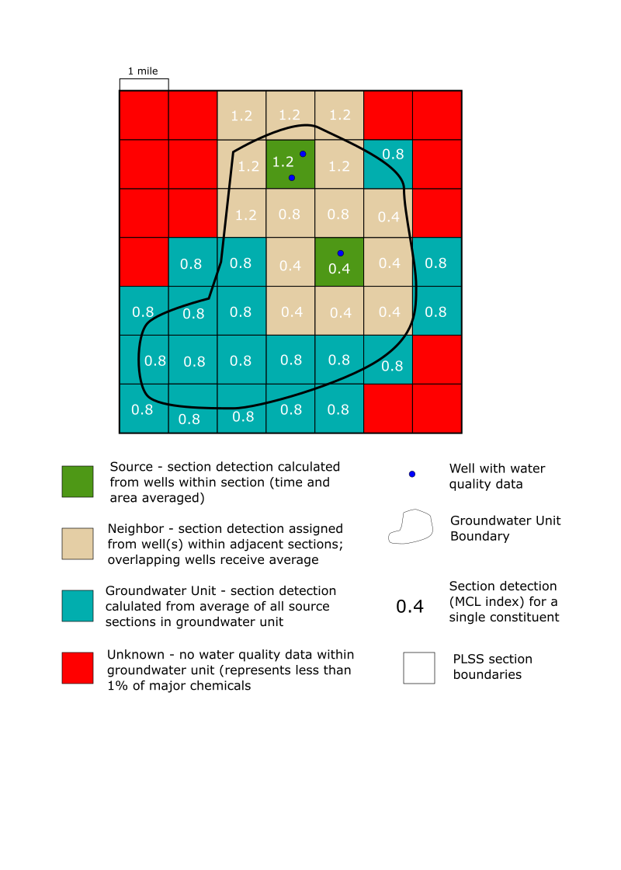

Figure 2. The relationship between source, neighbor, groundwater unit, and unknown sections. Water quality values (MCL indices) that would be assigned to each section are shown in white.

Within a groundwater unit, sections that do not qualify as a source or neighbor are assigned the groundwater unit average. This groundwater unit average is calculated for each chemical by taking the average of all source section MCL indices within the groundwater unit. Where a section intersects multiple groundwater units, the section value is calculated by averaging these groundwater units.

Some groundwater units do not contain water quality data that meets the depth-filtering criteria. Sections in these basins are assigned an “unknown” water quality value and are designated as *unknown* sections.  Depth-filtered groundwater quality data are available in 559 out of the 794 groundwater units that contain a domestic well (70 percent of groundwater units). The groundwater units without water quality data are sparsely populated and contain less than 1 percent of the domestic wells in OSCWR. Note that certain chemicals may have less coverage than this, so this percentage only represents the most widely sampled constituents. For full analysis of the data coverage achieved using this method, see Appendix C.

### Recent Data Analysis

Staff developed a water quality estimation layer based on the number of detections above an MCL within the last two years. This method is limited in scope because not all sections or chemicals have water quality data collected within the last two years. This method flags a section if there are one or more detections above the MCL in the last two years in that section, using the water quality data from the processed, depth-filtered dataset. Due to the sampling history of the datasets, most of the samples within the last two years are from public supply wells.

## Identification of Priority Sections

The focus of this project was to identify sections where groundwater that is likely accessed by domestic wells have a relatively greater likelihood of being affected by constituents above the MCL. This project identifies sections as “priority” status if the average historical water quality is greater than the MCL (i.e., has an MCL index > 1.0) or if the section was flagged as having a recent result above the MCL (one or more single sample[s] above the MCL within the last two years).

### Estimated Domestic Wells Located Within Priority Sections

The water quality layer from this project can be combined with a domestic well dataset to identify areas where domestic wells (and associated users) have a potentially greater likelihood of being affected by constituents above the MCL. For this project, domestic well section summary counts from the OSWCR dataset were used to estimate the potential number of domestic wells located within priority sections. In OSWCR, the summary statistics for domestic wells are based on the count of well completion reports that have “domestic” checked in the “Well Use” portion of the well completion report.

In the OSWCR database, most domestic well locations are attributed to the section level. As a result, section summaries are used in this project to represent counts and locations of domestic wells. To get an estimate of the percentage of domestic wells in priority sections, the count of OSWCR domestic wells in priority sections were totaled and compared to the number of OSWCR domestic wells statewide. For this project, all OSWCR domestic well counts were used, including in sections within the boundaries of a public water system.

It is important to note that the current OSWCR dataset may include inactive wells, duplicated records and missing data. Approximately 20 percent of all wells on OSWCR have no well type listed. Also, the current definition of “domestic wells” (well with four or less service connections) may not correspond with the designation of “domestic well” logs in the OSWCR database. Any future improvement in data quality could be combined with the water quality layer from this project to allow for a more accurate location of domestic wells within priority sections.

# Results

## Domestic Wells in Priority Sections

The most likely chemicals detected above the MCL in areas where groundwater is likely accessed by domestic users are arsenic, nitrate, 123-TCP, and radionuclides (Figure 3). Figure 3 shows the percentage of domestic wells in priority sections per chemical and the method used to flag those sections as priority (source or neighbor average detection above the MCL, groundwater unit average detection above the MCL, or recent detection above the MCL). The groundwater unit method has more uncertainty associated with it because the groundwater unit value is based on a relatively small set of individual water quality data points within the unit. For example, the percentage of domestic wells in nitrate or uranium priority sections has a greater relative certainty because these sections are mostly calculated from source/neighbor or recent concentrations above MCLs. Conversely, the percentage of domestic wells in 1,2,3-TCP priority sections is not as well defined, because a large percentage of the domestic wells are in sections with groundwater unit average detections above the MCL. This is even more apparent in the “TCPR123_2” water quality estimations (only 123-TCP data with reporting limits less than the MCL).

Many sections are marked as priority for more than one chemical. As a result, the total percentage of domestic wells in priority sections is significantly less than the sum of percentages per chemical shown on Figure 3. The methodology outlined here suggests that approximately 25 percent of all domestic wells in California are in priority sections. Staff found that only using twenty year averages (not using recent detections above the MCL) to determine priority sections reduces this percentage to 23 percent.

Figure 3. The percentage of domestic wells in priority sections by chemical. The colors show the method that was used to determine the status of the section containing the well (Source or Neighbor average detection above the MCL, Groundwater Unit average detection above the MCL, or recent detection above MCL within the section).

Figure 4 shows an example of the map output of this project for a single constituent (nitrate), for an area on the border of Fresno and Tulare counties. The water quality output is combined with the domestic well counts from OSWCR and public water system boundaries to show an example of how this information might be used.

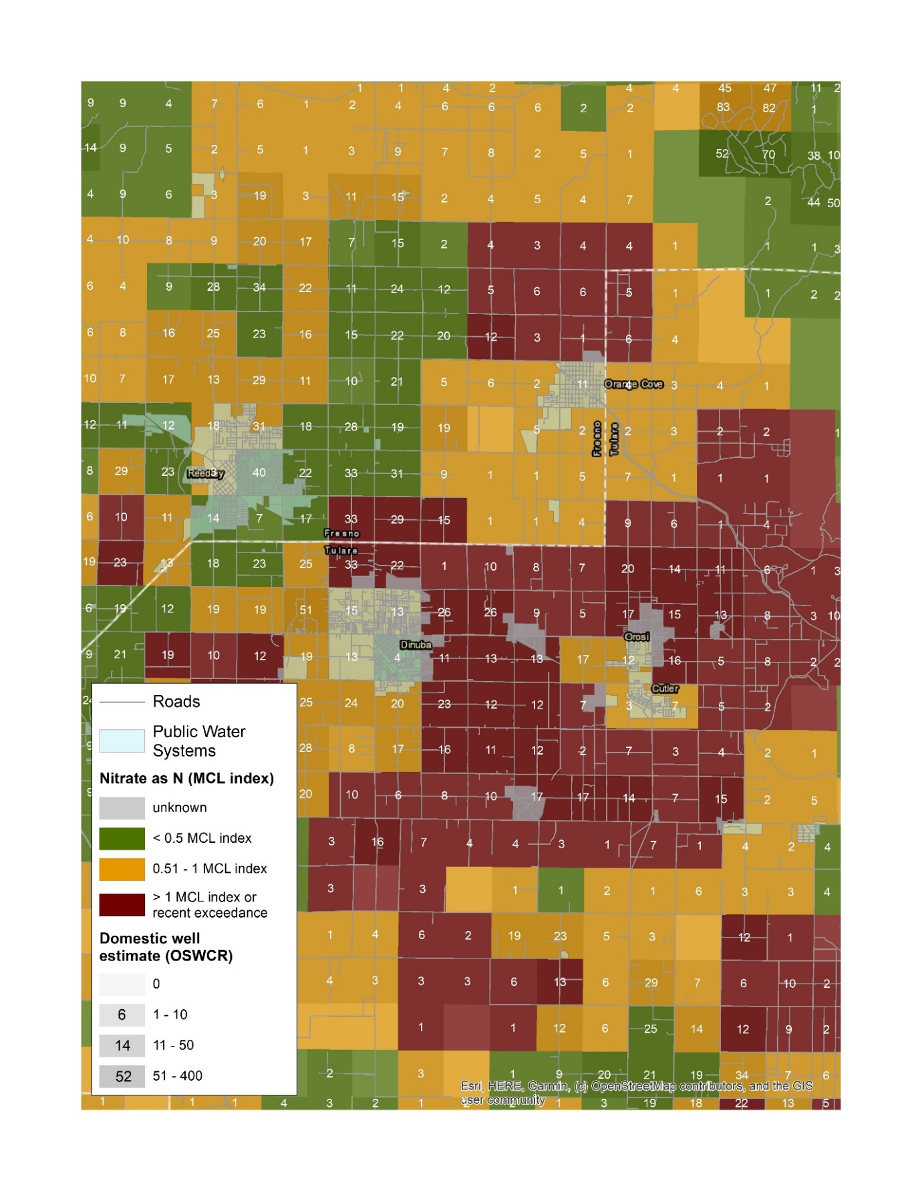

Figure 4. A close-up of an area of the state with a high percentage of priority nitrate sections. This map shows the PLSS sections colored according to their nitrate priority status (red – MCL index > 1 or recent detection above the MCL, orange – MCL index between 0.5 and 1, and green – MCL index <= 0.5). The white numbers and the shading of the sections show the OSWCR estimates for domestic well completion reports within each section, giving an estimate for the number of domestic wells affected. The outlines of public water systems are also shown for reference.

## Secondary Maximum Contaminant Level Chemicals

Including the SMCL chemicals increases the percentage of domestic wells in priority sections from approximately 25 percent (only constituents with an MCL) to approximately 60 percent (constituents with an MCL or an SMCL). Figure 5 shows that most of these additional domestic wells are from priority sections with manganese and iron detections above drinking water standards.

Figure 5. The percentage of domestic wells in priority sections per chemical. The colors show the method that was used to determine the status of the section containing the domestic well (Source or Neighbor average detection above the MCL, Groundwater Unit average detection above the MCL, or recent detection above the MCL in that section).

1. Data Standardization

Water quality data obtained from the GAMA Groundwater Information System were standardized using the following steps:

1. Duplicates: Results from USGS-GAMA studies that are duplicated in the NWIS dataset were removed by performing a crosswalk between these two datasets. For the USGS “Vanadium Study” wells, the NWIS duplicates were kept, as the method of averaging outlined below requires a unique name for each well, and these eight wells all share the name “Vanadium Study” in the USGS dataset but have unique names in the NWIS dataset.
2. Nitrate/nitrite (NO3NO2N) combined conversion: In some cases, nitrate results for a single sample analysis is reported for combined NO3NO2N, NO3N and NO2. To prevent double counting of nitrogen (N) analyses in these cases, if NO3NO2N, NO3N, and NO2 were recorded for a single sampling event, staff removed the NO3NO2N record. If only NO3NO2N and NO2 were recorded for a single sampling event, staff kept the NO2 value and calculated NO3N by subtracting NO2 from NO3NO2N. If only NO3NO2N was recorded, staff accepted that as the NO3N value. The decision to substitute total NO3NO2N in for NO3 in these cases was to allow for total N data to be compared to cases where NO3N was reported only. Rationale for substituting total NO3NO2 for N03 was:
   1. Total NO3NO2 and NO3 have the same MCL, so MCL considerations for these two reported analytes is expected to be comparable.
   2. In most cases, groundwater nitrogen predominates as NO3, so NO3 is similar in magnitude to NO3NO2N.
3. Standardizing qualifiers: The “QUALIFER” column in the GAMA GIS database has several values, including (“NA”, “ND”, “-”, “I”, “<”, “Q”, etc.). To standardize these values, all values of “ND” and “<” received a standardized qualifier of “<”. All other values were converted to “=”.
4. Detections with no numerical data: Staff removed measurements where the RESULTS column had “NA”, the Reporting Limit column had “NA”, and the QUALIFER column had “=”, as no numeric result could be assigned. This accounted for approximately 0.007% of sample results.
5. Assigned reporting limits: Samples listed as “non-detects” (QUALIFER of “<” or RESULTS of “0”), without a numeric reporting limit or result were assigned a reporting limit based on a time-weighted distribution of actual reporting limits for that chemical. Staff assigned a reporting limit by looking for the closest earlier reported reporting limit of the same chemical. If there is no earlier reporting limit, staff used the closest subsequent reported reporting limit. The date that the assigned reporting limit is taken from is recorded as metadata. Staff assigned reporting limits to approximately 50% of all sample records.
6. Single numeric entry per record: Staff converted each result or reporting limit to a single numeric entry per record. If the sample was a detection (QUALIFER “=” and RESULTS > RL) this numeric entry is taken as the RESULTS. If the sample was a non-detection (QUALIFER “<” or RESULTS <= RL or RESULTS <= 0) the numeric entry is $\frac{Reporting Limit}{\sqrt{2}}$. If this value is greater than half of the MCL for that chemical, the numeric entry is $\frac{MCL}{2}$. This conversion was completed to ensure that non-detects do not register as exceeding the MCL. The reporting limit is greater than the MCL for approximately 2% of the records (Table A-1). Note that the reporting limits compared here are composed of actual reporting limits and reporting limits assigned by staff in step 5.

|  |  |
| --- | --- |
| CHEMICAL | Count of sampling records where reporting limit > MCL |
| TCPR123 | 90,719 |
| DBCP | 46,302 |
| EDB | 43,251 |
| DOA | 15,730 |
| HEPTACHLOR | 9,866 |
| PCP | 8,056 |
| BIS2EHP | 7,823 |
| HEPT-EPOX | 4,876 |
| NNSM | 4,507 |
| BZAP | 4,496 |
| FC113 | 2,300 |
| SB | 1,007 |

Table A-1. This table summarizes the counts of sampling records where the reporting limit is greater than the MCL, by chemical. All together, these counts make up 2% of the total water quality records used in this project. Only chemicals with counts above 1,000 are shown in this table

1. A significant number of 1,2,3-TCP analyses results have an analytical reporting limit higher than the current MCL (n = 9,355). The available data for 1,2,3-TCP was unique in this aspect due to relatively recent advancements in the analytical method and the relatively low value for the MCL (0.005 micrograms per liter) for this compound. As a result, use of the approach described above for 1,2,3-TCP would result in a potentially large population of historical results that were above the MCL not captured because they are recorded as “below reporting limit”. Additionally, a further 131,890 records did not have a reporting limit associated with the record, and when staff assigned a reporting limit (step 5), 90,719 records have a reporting limit higher than the MCL, over half of the total number of 1,2,3-TCP records. To address this concern, two 1,2,3-TCP water quality analysis layers were created. The first (“TCPR123”) follows the data processing methodology used for all other chemicals, outlined above, and utilizes all 1,2,3-TCP records available. The second (“TCPR123_2”) calculates water quality using only 1,2,3-TCP data that has a known reporting limit that is less than the MCL. This decreases the total number of 123-TCP water quality results from ~160,000 to ~3,600 sampling results. This (more stringent) filter results in less coverage of the state, but results in more accurate recording of detections above the MCL. Note that even though two water quality layers are reported for 1,2,3-TCP, they should not be used simultaneously in any statewide summary statistics that aggregates chemical results together. All summary statistics presented in this paper use the TCPR123 water quality layer unless specified otherwise. Currently, the map layer available via the GAMA Online Tools displays the “TCPR123” layer, but the “TCPR123_2” layer can be accessed [separately](https://gispublic.waterboards.ca.gov/portal/home/item.html?id=ffb3a4a673414cf48a8c70c8e15ade77).
2. Staff investigated several methods to address the population of records with non-detect results. A summary of results from that investigation is provided in Table A-2, below. Staff selected method 2 (described above in step 6) as the most appropriate way to incorporate non-detect data without having that data overly influence the analysis results. Methods 4 and 5 were overly affected by records where non-detects were greater than the MCL. Method 1 did not account for non-zero non-detect results, and method 3 did not as good statewide coverage as method 2.

|  |  |  |  |
| --- | --- | --- | --- |
| Method | Method for Handling Non-detect Result | % of domestic wells in priority sections for each method of non-detect handling | Top 4 constituents |
| Method 1 | RLs taken as 0 | 21.1% | AS, 123-TCP, ALPHA, NO3N |
| Method 2 | RLs converted to RL/sqrt(2), RLs > MCL as MCL/2* | 26.8% | 123-TCP, AS, ALPHA, NO3N |
| Method 3 | RLs as RL/sqrt(2), all RLs > MCL removed | 26.3% | 123-TCP, AS, ALPHA, NO3N |
| Method 4 | RLs as RL/sqrt(2) | 96.2% | 123-TCP, DOA, HEPTACHLOR, DBCP, PCP |
| Method 5 | RLs as RLs | 97.2% | 123-TCP, DOA, HEPTACHLOR, PCP, HEPT-EPOX |

Table A-2. This table summarizes the results (the percentage of domestic wells in priority sections statewide, for all chemicals and the top four constituents with priority sections) for different methods of handling non-detects. *1,2,3-TCP results where RL > MCL or RL is unknown are removed.

1. Outliers: Staff defined an outlier as a result that is equal to or greater than ten standard deviations above the mean for all detections of each chemical. Any detections above this cutoff were removed from the dataset used for calculation.
2. Leading zeros in well names: Through data processing (saving the well name lists as a file, importing and exporting data in ArcGIS), some well names were changed by adding or dropping leading zeros. To maintain consistency, staff adjusted well names from the GIS output (left column) to match the well names associated with the water quality results (right column).

|  |  |
| --- | --- |
| Well name in water quality results | Well name from GIS output |
| 01050601 | 1050601 |
| 060201 | 60201 |
| 01043002 | 1043002 |
| 1012421 | 010124221 |
| 1012416 | 01012416 |

Table A-3. Example of adjustments to well names so that water quality results matched up with GIS well names

1. Well Depth Filter

This section describes the steps taken to filter available groundwater data to focus this assessment on water quality typically accessed by domestic wells and screen out data that would be more likely to represent deeper groundwater.

1. In ArcGIS, intersect OSWCR section data with groundwater unit boundaries to generate a dataset of OSWCR domestic well depth statistics by section, sorted by groundwater unit. Sections that overlap two or more groundwater units are included in the summary statistics for each groundwater unit the section intersects.
2. Define Group 1 depth filter for wells with known numeric depths: per groundwater unit, take all wells (domestic and public) with depths between Domestic Bottom depth and Domestic Top depth. Where **Domestic Bottom** = average of section maximum domestic well depths + 3 standard deviations of section maximum well depths for each groundwater unit. Where **Domestic Top** = average of section minimum domestic well depths - 3 standard deviations of section minimum well depths for groundwater unit.

Take the average and standard deviation of the maximum domestic well depths (“Total Completed Depth”) reported for every section in the basin. Sections with no well depth data reported are not counted in the average. Report the basin average maximum domestic well depth and a 3 standard deviation maximum depth, defined as average maximum depth + 3 standard deviations deeper. If there are two or less sections used to calculate the basin average maximum well depth, an estimated 150 ft standard deviation is applied, and the 3 standard deviation maximum depth is defined as the average maximum well depth + 3*150 ft. 150 ft represents an average standard deviation for all basin calculations.

*Example: A groundwater unit contains sections with the following maximum domestic well depths: 100 ft, 150 ft, and 125 ft depth. The groundwater unit average maximum domestic well depth is 125 ft, and the standard deviation is 20.4 ft. The Domestic Bottom would be 186 ft.*

1. Define Group 2 depth filter for wells of unknown numeric depths, but with known use (“domestic”, “public”, etc.): Per groundwater unit, public and domestic wells are included in domestic well depths if Public Bottom is less than or equal to Domestic Bottom OR the % difference between Public Bottom and Domestic Bottom (defined as $\frac{|Pb-Db|}{\frac{(Pb+Db)}{2}}$ x100) is ≤ 10%, where Pb and Db are Public Bottom and Domestic Bottom, respectively. If either the Public Bottom or Domestic Bottom depths are not defined for a groundwater unit (no wells reported in OSWCR) then the public and domestic wells are assumed to be in different aquifers. If Public Bottom if greater than Domestic Bottom and the % difference between the two is greater than 10%, public wells are not included in the domestic well depth filter for that groundwater unit. Where **Public Bottom** = average of section maximum public well depths + 3 standard deviations of section maximum well depths for groundwater units (same methodology as determining Domestic Bottom above, but only using public well depths). See Figure 6 for Group 2 filter results.
2. Normalize depths of wells with water quality (Group 1) to one number (depth is either reported as “well depth”, or a combination of “screen length” and “depth to screen top”. If a well has a “well depth” listed, that is used. If a well does not have a “well depth”, but has screen information, the depth of the well is the “screen length” added to the “top of screen depth”. If TOP_SCREEN = -SCREEN_LEN (giving a well depth of zero), divert the well to Group 2 “use” filter.
3. A “yes” in the “domesticdepth” column means that the well meets the depth filter criteria for either Group 1 or Group 2. A “no” means it does not. A “NA” means that there were no domestic wells in the GU and thus staff could not determine criteria for filtering domestic wells. Eliminating these water quality wells is acceptable for this methodology because these basins/sections without domestic wells will not be part of the final output.

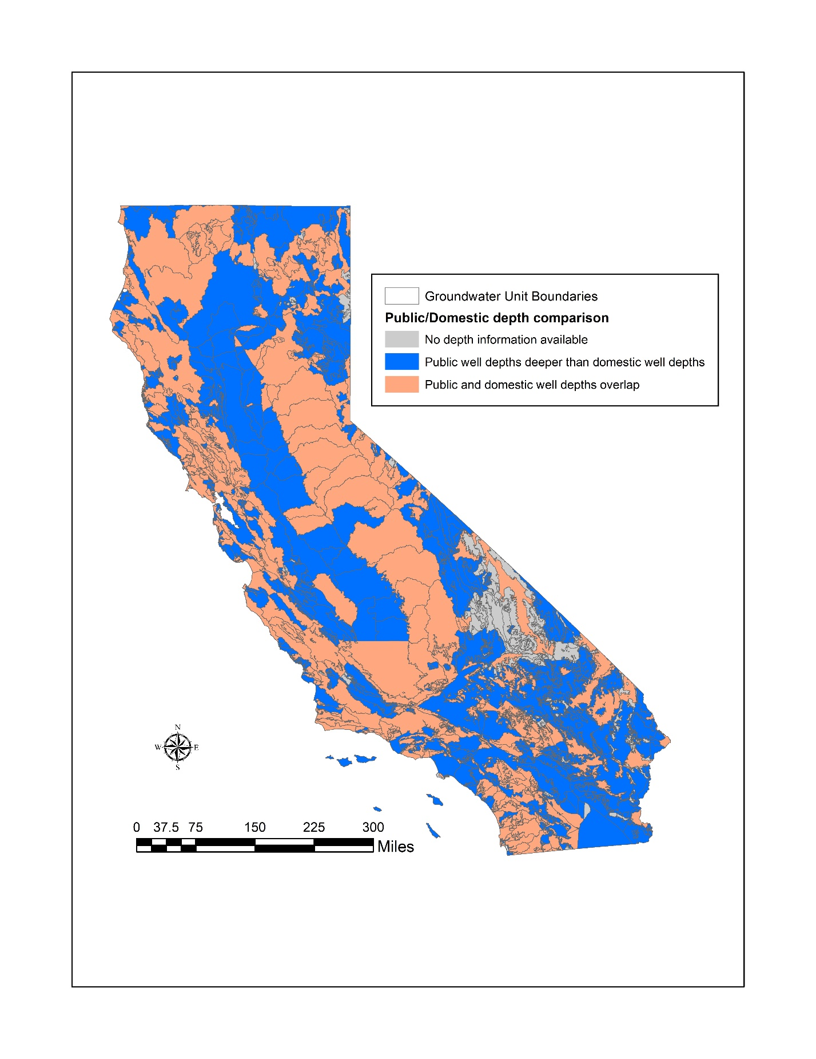

Figure 6. Map showing results of Group 2 (use depth filter). Groundwater unit sections in blue have public well depths that are significantly different than domestic well depths, while units in orange have similar domestic/public well depths.

1. Data Coverage

Figure 7. The statewide coverage achieved by this methodology for domestic wells. 48 of the 96 chemicals analyzed are included on this graph. Overall, the method presented in this paper covers more than 98% of domestic wells most chemicals with an MCL.

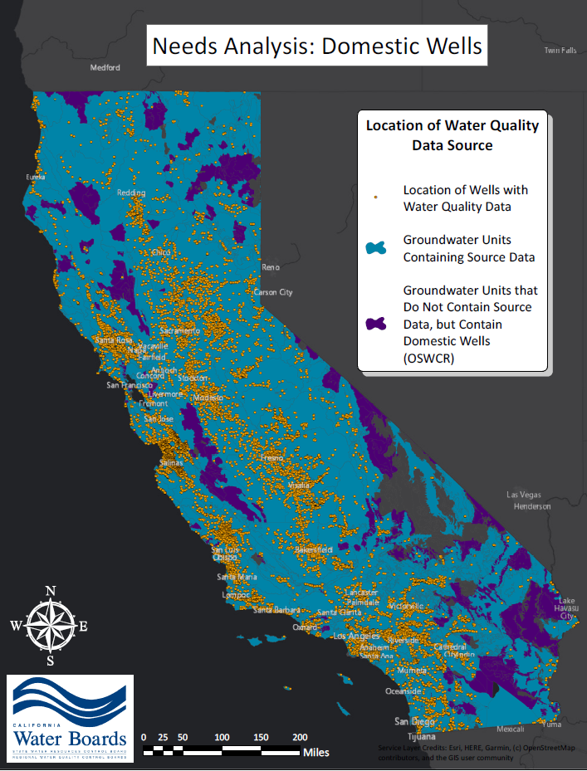

Figure 8. Statewide scale of wells with water quality data that passed the depth filter, with groundwater units.

1. Sensitivity Evaluation

A sensitivity analysis was conducted on the timeframe selected for water quality data and on the use of the depth filter to assess the impacts these variables had on the results.

## Timeframe for Including Water Quality Data

Increasing the timeframe (including older data) can increase the coverage of areas with water quality data. However, including older data may introduce results that are no longer representative of current conditions, and averaging over this longer timespan may obscure recent results. As shown in Figure 9, and as expected, water quality data coverage as measured by the number of source sections decreases as with the time span.

Figure 9. Source data coverage for sections based on wells that meet the domestic depth criteria are displayed, for the three time spans discussed in the text. A reference for the maximum possible data coverage (20 years of data, no depth filter) is presented in grey as a comparison.

The calculations were run using five, ten, and twenty years of water quality data to assess the impact of these timeframes on the resulting percentages of domestic wells in priority sections (Figure 10). To isolate the effect of the water quality data time span on the section averages, for this comparison “priority” only includes sections where the average water quality is above the MCL. Recent results above the MCL flags are not included, as that data is only based on a two-year time span.

For most chemicals, including older data predicts a higher percentage of domestic wells in priority sections (e.g., 1,2,3-TCP (TCPR123_2), gross alpha, nitrate, bromate, DBCP, and fluoride). For these chemicals, fewer domestic wells are in priority sections if only more recent data is used. For arsenic and lead, there is no clear relationship between timespan of data and percentage of domestic wells in priority sections. For uranium and 1,2,3-TCP (TCPR123), running the assessment calculations with more recent water quality data (smaller time span) results in a higher percentage of domestic wells in priority sections. It’s not clear if this difference is due to real trends in water quality or due to sampling distribution or bias in our methodology.

Changing reporting limits and laboratory capabilities over time may have an impact as well. The differences in “TCPR123” and “TCPR123_2” results suggest that sampling distribution and reporting limit changes have a strong impact on these trends. These trends were part of the basis to include the layer discussed above that identifies areas with a recent detection above the MCL.

Figure 10. The percentage of domestic wells in priority sections for each time span, by chemical. Only data that passes the depth filter criteria are included. *Priority sections here are defined as sections where the average water quality is above the MCL for that chemical.

Overall, staff concluded that a 20-year timeframe was appropriate for this analysis based on the increase in areal coverage. Use of this timeframe allowed inclusion of some important specialized studies of domestic wells that were conducted during the 2000s.

## Depth Parameters

To focus this assessment on the groundwater resource used by domestic wells, only water quality data that passes the depth filter (described above) is assessed. While this filtering decreases the source section and groundwater unit coverage (Figure 9), it has the benefit of screening out data that is more representative of deeper portions of aquifers that are less likely to be impacted.

|  |  |  |  |  |
| --- | --- | --- | --- | --- |
| Dataset Source | All data – last 20 years (wells) | All data – last 20 years (sampling records) | Depth filter applied – last 20 years (wells) | Depth filter applied – last 20 years (sampling records) |
| DDW | 18,670 | 8,386,479 | 11,717 | 5,160,183 |
| GAMA | 1,147 | 56,996 | 1,147 | 56,993 |
| USGS/NWIS | 5,855 | 247,578 | 4,814 | 244,207 |
| DWR | 757 | 22,528 | 411 | 8,568 |
| LOCALGW/AGLAND | 7,053 | 246,808 | 4,856 | 239,057 |
| **Total** | 33,482 | 8,987,389 | **22,945** | **5,709,008** |

Table 4. Summary of groundwater quality data used in this project. Statistics of wells and sampling records are displayed for all data available, and for cleaned and filtered data used in this project.

To observe the effect of using this depth filter compared to using all well water quality data, staff compared the percentage of domestic wells in priority sections for the twenty-year assessment with and without the depth-filter. The results for the 20-year dataset are shown in Figure 11. The effect of the depth filter on the percentage of domestic wells in priority sections varies by chemical. When the comparison is done at a smaller basin scale, the difference in the percentage of domestic wells in priority sections is more significant.

Figure 11. The change in percentage of domestic wells in priority sections when no depth filter is applied to water quality data vs. when the depth filter is applied to water quality data.

1. Comparisons with other water quality analyses

Water quality results from this project were compared with results from similar published studies of water quality in California. No other study covers the entire state or all chemicals with an MCL, so comparisons can only be done for parts of the state and for certain chemicals. Staff compared the results from this methodology to modeling studies in the Central Valley ([Ransom et al., 2017](https://www.sciencedirect.com/science/article/pii/S0048969717313013)) and statewide basins ([Anning et al., 2012](https://pubs.usgs.gov/sir/2012/5065/)), and to water quality results collected by the [USGS Shallow Aquifer Assessment Study](https://ca.water.usgs.gov/projects/gama/gama-domestic-groundwater-well-sampling.html). The results from this methodology were also compared visually to the CV-SALTS Upper Zone nitrate estimations in the Central Valley. Except for the Anning et al., 2012 study, all these methods focused on domestic or shallow well water quality.

To compare the results from this project with other studies staff calculated the count of domestic wells (from OWSCR section summary statistics) in sections where the average water quality was greater than the MCL or there was a recent detection above the MCL for each chemical sampled or modeled in the comparison study. The water quality results (this project) and domestic well count data are in mile by mile PLSS sections, following the methodology outlined above.

None of the other studies had data at the resolution of mile by mile PLSS sections, so staff calculated the range of domestic wells in priority sections predicted by the other studies. The “minimum” represents the scenario where the lowest intersecting grid cell value is assigned to each PLSS section, “maximum” is where the highest intersecting grid cell value is assigned to each PLSS section, and “average” is the average of all intersecting grid cell values for each PLSS section. OSWCR section summary statistics counts of domestic wells were used for all comparisons. To accurately compare the other studies with the estimations from this project, only areas where both studies have known water quality data are compared.

## Ransom et al. (2017) Central Valley nitrate prediction – domestic well depth

Ransom et al. (2017)[5] developed a boosted regression tree model to predict nitrate concentrations in the Central Valley. This model combines nitrate data from the Central Valley with several predictor variables and uses machine learning to develop nitrate groundwater concentration predictions at a variety of depths. Since this project is focused on water quality at domestic well depths, staff used the 180 feet (54.86 meters) Ransom et al. (2017) prediction surface as a comparison. This depth represents the median private supply well depth in the Central Valley, according to Ransom et al. (2017). Staff calculated the percentage of domestic wells in priority sections according to the nitrate predictions from Ransom et al. (2017). In the Ransom et al. (2017) modeling results, a grid cell is “priority” status if the predicted value is greater than the MCL. The grid cell size for Ransom et al. (2017) was one square kilometer (oriented northwest/southeast).

The nitrate results for both methods show a similar percentage of domestic wells in priority sections with a similar spatial distribution. According to this project, approximately 8% of domestic wells in the Central Valley are in nitrate priority sections. According to the prediction surface developed by Ransom et al. (2017), approximately 1% - 11% (average: 4%) of domestic wells in the Central Valley are in nitrate priority sections. Both methods indicate high concentrations of priority nitrate sections in the northern San Joaquin and south-eastern San Joaquin Valley (Figure 12).

## Anning et al. (2012) USGS Basin Predictions for Nitrate and Arsenic

This 2012 USGS report[6] uses machine learning to estimate nitrate and arsenic concentrations in groundwater basins throughout the southwestern United States, including California. The report combines nitrate and arsenic data with predictor variables such as geology, land use, groundwater flow paths, and aquifer characteristics to predict concentrations in basins statewide. The predicted concentrations are for the 200-foot aquifer penetration depth.

In this prediction model, a grid cell is “priority” status if the predicted value is greater than the MCL. To perform this analysis, staff converted the concentration ranges provided into average concentrations. For example, nitrate class 4 grid cells (value range 2 – 4.9 mg/L) were converted to a value of 3.5 mg/L, or an MCL index of 0.35. Similarly, arsenic class 6 grid cells (value range 10 – 24 ug/L) were converted to a value of 17 ug/L, or an MCL index of 1.7.

In comparison with the USGS basin predictions, the methodology presented in this paper results in similar but slightly higher percentages of domestic wells in priority sections on average. For basins with available nitrate data, the method presented in this paper predicts 7.8% of domestic wells as located in priority nitrate sections and the USGS modeling predicts 6.1%. For basins with available arsenic data the method presented in this paper predicts 10% of domestic wells as located in priority arsenic sections whereas the USGS modeling predicts 8.3% of domestic wells. The spatial distribution of arsenic priority sections is similar for the two studies, with a high density of arsenic priority sections predicted in the Mojave region and parts of the Central Valley by both studies (Figure 13). The spatial distribution for nitrate priority sections differs slightly between the two models, with the USGS model predicting nitrate priority sections in the central and southwestern San Joaquin Valley and the methodology presented in this paper suggesting nitrate priority sections in the central and southeastern San Joaquin Valley and the Salinas Valley.

## USGS Shallow Aquifer Assessment Study Areas

The Shallow Aquifer Assessment Study is an ongoing USGS-GAMA sampling project where shallow or domestic wells are sampled in high-priority basins across the state. Data is collected from spatially un-biased grid cells to achieve full coverage of the study area through representative wells. Staff compare the percentage of domestic wells in priority sections for all chemicals sampled by the USGS in six of the study areas – North San Francisco, Monterey/Salinas, Madera/Chowchilla (MACK), Tule/Tulare/Kaweah/Highlands (TUSK), Mokelumne/Cosumnes/American River (MCAW), and Yuba/Bear. The Shallow Aquifer study areas were sampled in 2012 (North San Francisco), 2012-2013 (Monterey), 2012-2014 (MACK), 2014-2015 (TUSK), 2016-2017 (MCAW), and 2015-2019 (Yuba/Bear). Note that data collected from the Shallow Aquifer Assessment Study is part of the water quality dataset used to calculate section detections for the method presented in this paper.

In the USGS Shallow Aquifer Assessment Study, a grid cell is “priority” status if the sampled well within the cell had a detection above the MCL, as designed by the USGS study where a single well represents the water quality for the entire grid cell. Some USGS grid cells do not have an associated sampling well and are indicated in grey as “unknown” (these areas were not included in the numeric comparison but are displayed on the map for comparison).

The method presented in this paper estimates similar locations of priority nitrate sections as the USGS Shallow Aquifer Assessment (Figure 14). Additionally, in general both studies estimate a similar percentage of domestic wells in priority sections (Figure 15). However, the method presented in this paper estimates slightly fewer domestic wells in nitrate priority sections in several study areas. Even though the method presented in this paper tends to under-predict the percentage of domestic wells in nitrate priority sections compared to the USGS Shallow Aquifer studies, it over-predicts domestic wells in nitrate priority sections compared to Ransom et al. (2017).

## CV-SALTS Central Valley Upper Zone Nitrate

CV-SALTS developed a prediction surface for nitrate in the Upper Zone of groundwater basins in the Central Valley, which is visually compared to the nitrate estimation from the methods presented in this paper (Figure 16). The results could not be numerically compared because staff do not have access to the numeric CV-SALTS results by grid cell. A visual comparison shows that CV-SALTS predicts more areas with nitrate values above the MCL (> 10 mg/L) than either the method presented in this paper or the Ransom et al. (2017) method. However, the general areas with predicted nitrate values above the MCL are the same areas between all studies. The generally more extensive areas with nitrate > 10 mg/L indicated by the CV-SALTS analysis likely reflects that that analysis included water quality data from monitoring wells, which represent groundwater quality data from shallower depth intervals potentially closer to source areas.

Select chemicals and areas of comparison are presented below in spatial (map) format (Figures 12-14, 16). Additionally, numeric comparisons are displayed for select chemicals and studies (Figure 15).

## Human Right to Water Tool

The Office of Environmental Health Hazard Assessment (OEHHA) is developing a tool to evaluate several metrics of the state drinking water supply, and identify systems that face challenges in supplying clean, affordable, and accessible drinking water. The current draft of the tool assesses community water systems. Since the current draft does not identify metrics for domestic wells, staff could not compare methodologies or results at this time. However, future drafts of the tool may assess domestic wells, in addition to state small water systems and tribal areas. OEHHA is currently working to improve domestic well distribution data and apply that improved data to domestic well water quality estimates.

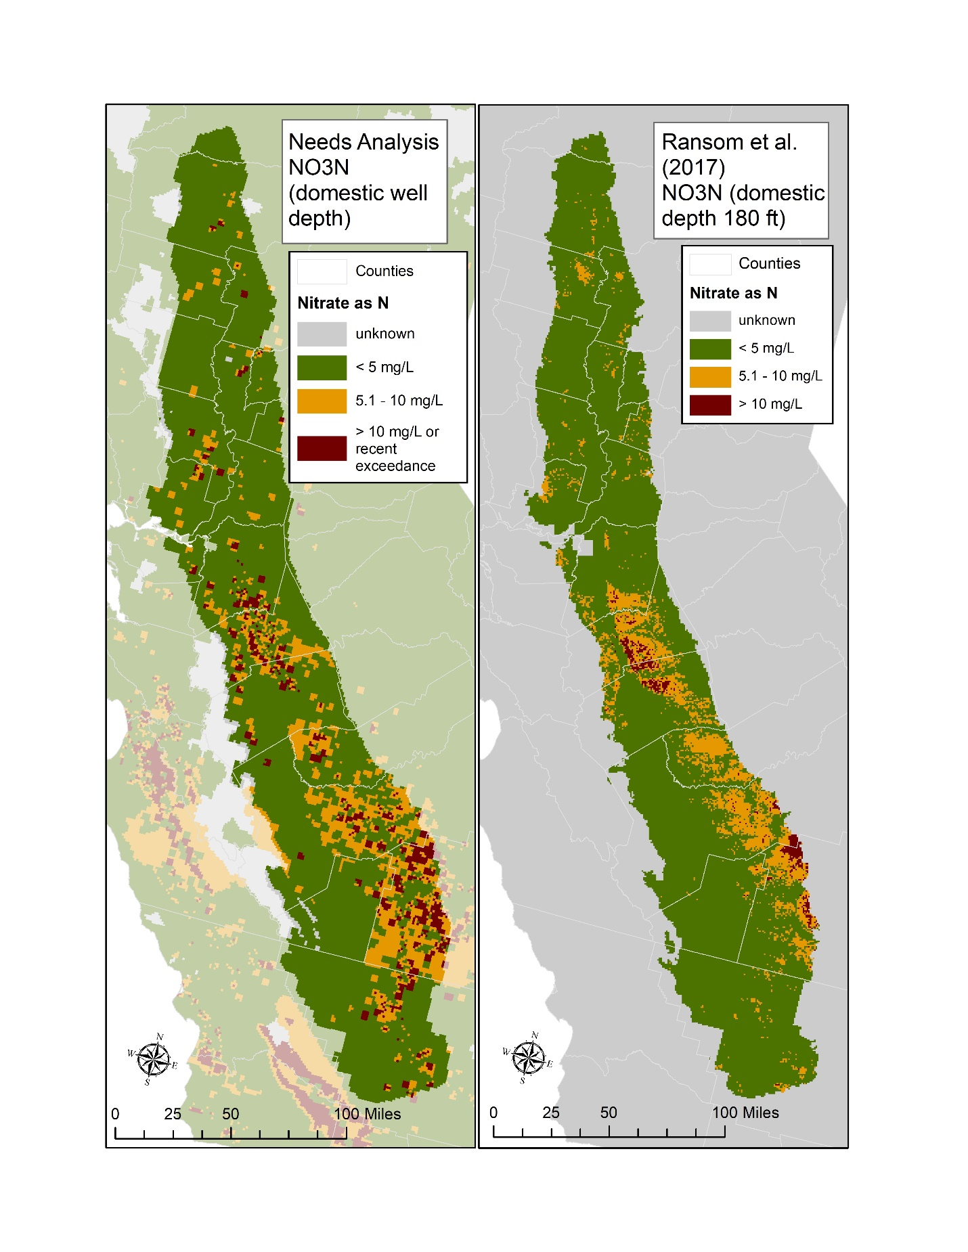

Figure 12. A visual comparison of nitrate results from this project (left) and the modeling results from Ransom et al. (2017) (right). The Ransom et al. results utilize the 180-foot depth predictions, which represent median domestic well depths in the Central Valley.

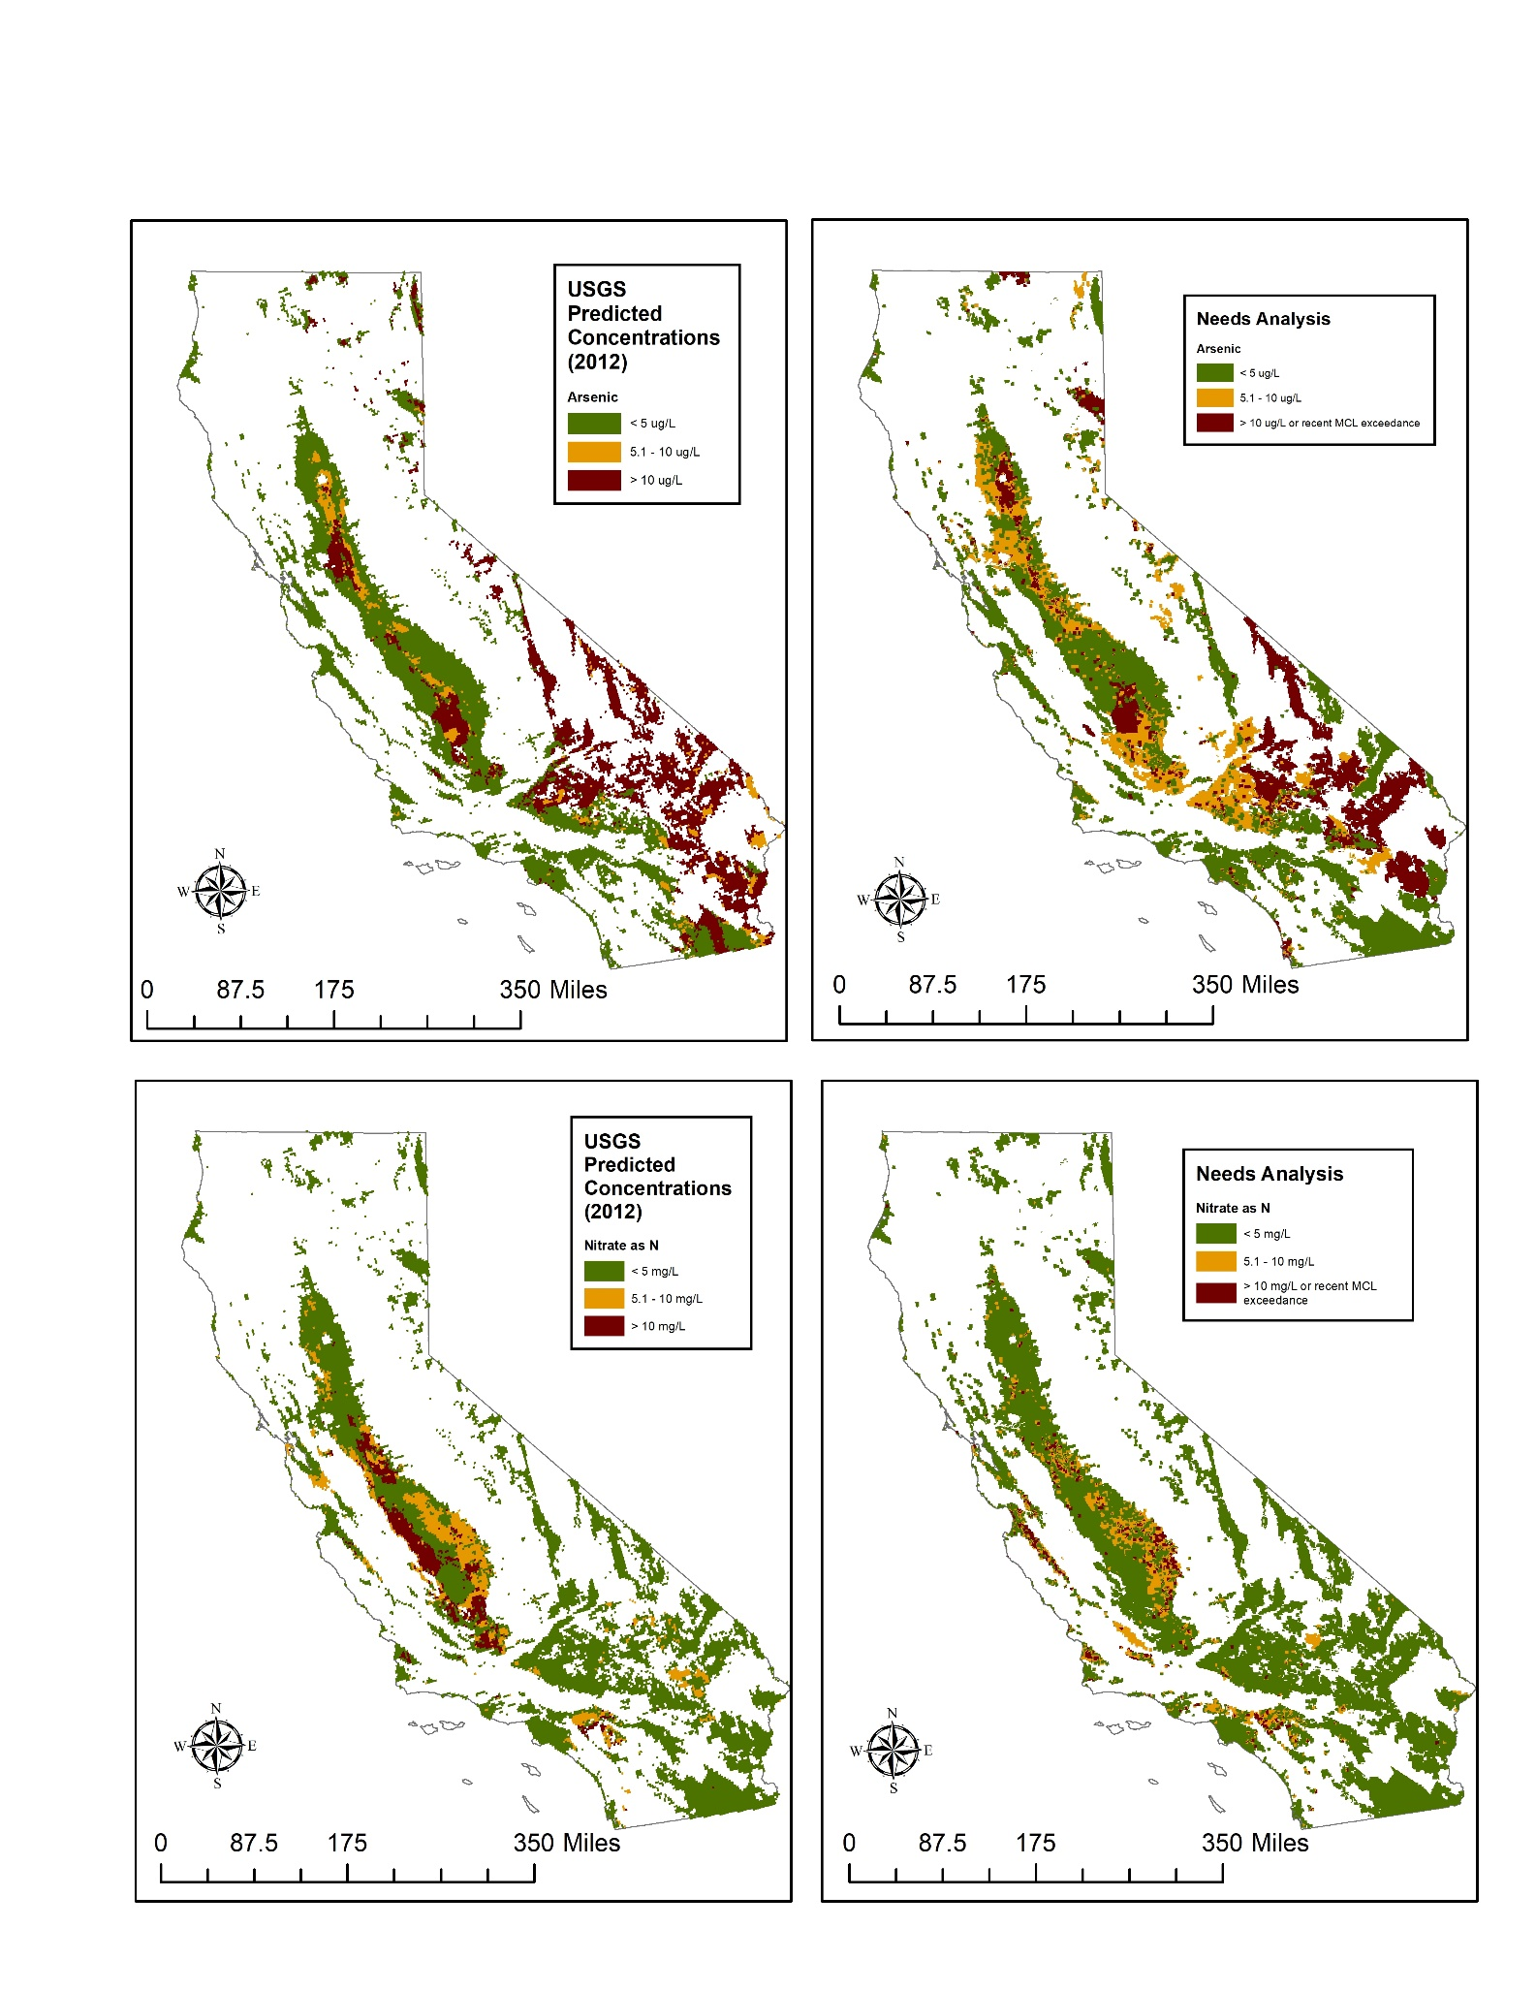

Figure 13. A visual comparison of the methodology presented in this paper (right) and the Anning et al. (2012) USGS Southwestern Basin Prediction Concentrations (left) for arsenic (top) and nitrate as N (bottom). Only areas with data for both studies are shown here.

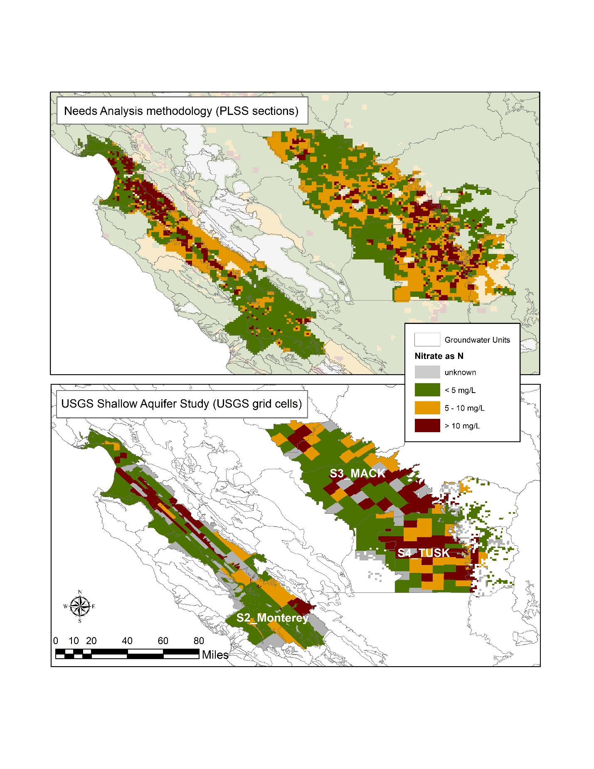

Figure 14. Visual comparison of nitrate concentrations estimated by this project (top) and water quality data from USGS Shallow Aquifer Assessment Studies (bottom). Three USGS study areas are shown (Monterey/Salinas, Madera/Chowchilla (MACK), Tule/Tulare/Kaweah/Highlands (TUSK)). USGS grid cells in grey mean that no well was sampled within that grid cell, so water quality is unknown. These unknown grid cells were excluded from comparison.

Figure 15. These graphs show the numeric comparison for percentage of domestic wells in priority nitrate sections (A, top) and priority arsenic sections (B, bottom). *Priority sections is defined for this project a section with an average detection above the MCL or a recent detection above the MCL, and for the other studies as a predicted or measured value above the MCL within the section.

To visually compare the CV-SALTS basin predictions with the results presented in this paper, the nitrate map from this project was assigned the same color breaks as the CV-SALTS map, with the same RGB color values representing each bin.

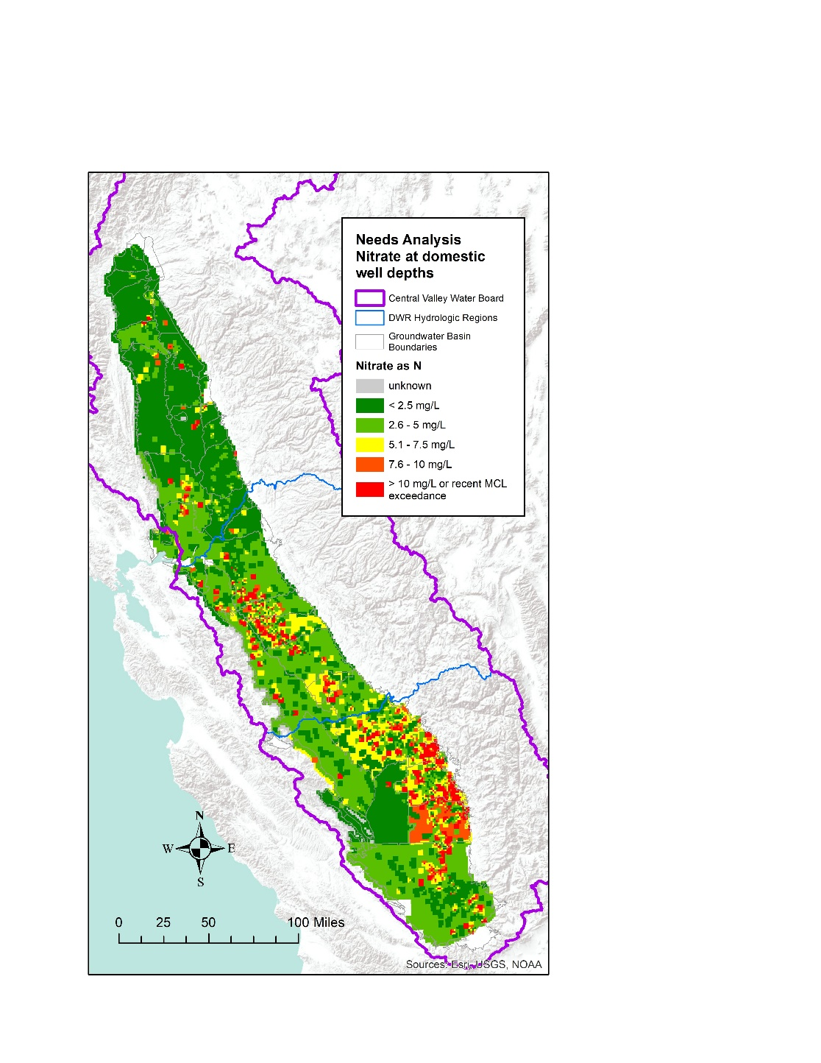A map of the Central Valley showing areas of high nitrate concentration according to the CV-SALTS study.

Figure 16. A visual comparison of this project (left) and CV-SALTS prediction model (right) for nitrate concentrations in the Central Valley. Note that the groundwater basin boundaries (grey) used in this project are the Bulletin 118 boundaries, whereas the groundwater basin boundaries (grey) used in the CV-SALTS model are Initial Assessment Zones (IAZs) which are slightly different.

1. This project uses Groundwater Units as areas of analysis. Groundwater Units consist of groundwater basins as defined by [DWR Bulletin 118](https://water.ca.gov/-/media/DWR-Website/Web-Pages/Programs/Groundwater-Management/Bulletin-118/Files/B118-Interim-Update-2016.pdf), and the connecting upland areas associated with each of these basins as delineated by the [USGS](https://www.sciencedirect.com/science/article/pii/S2214581814000305?via%3Dihub). Use of Groundwater Units results in coverage of the entire state. Averaging of well depths and groundwater quality within a Groundwater Unit was considered reasonable based on the assumed relative consistency of hydrogeologic conditions within each Unit.
2. Domestic Bottom = average of section maximum domestic well depths (from OSWCR) plus 3 standard deviations of section maximum well depths for each groundwater unit.
3. Domestic Top = average of section minimum domestic well depths (from OSWCR) minus 3 standard deviations of section minimum well depths for groundwater unit.
4. Public Bottom = average of section maximum public well depths (from OSWCR) plus 3 standard deviations of section maximum well depths for groundwater units.
5. Ransom, K.M., Nolan, B.T., Traum, J.A., Faunt, C.C., Bell, A.M., Gronberg, J.M., Wheeler, D.C., Rosecrans, C.Z., Jurgens, B., Schwarz, G.E., Belitz, K., Eberts, S.M., Kourakos, G., and Harter, T., 2017, A hybrid machine learning model to predict and visualize nitrate concentration throughout the Central Valley aquifer, California, USA: Science of The Total Environment, vol. 601-602, p. 1160 – 1172.
6. Anning, D.W., Paul, A.P., McKinney, T.S., Huntington, J.M., Bexfield, L.M., and Thiros, S.A., 2012, Predicted nitrate and arsenic concentrations in basin-fill aquifers of the Southwestern United States: U.S. Geological Survey Scientific Investigations Report 2012–5065, 78 p.